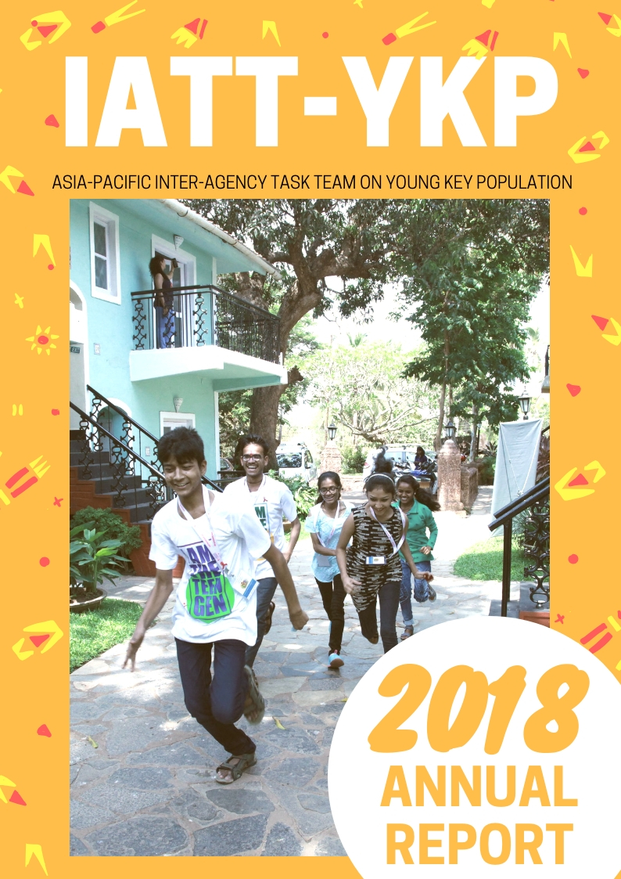
Contents
About the Inter Agency Task Team on Young Key Populations 3
2018 Annual Report 4
Highlights in 2018 5
En Route to Adulthood Brainstorming Workshop 5
TeenGen Leadership Programme 5
Regional Training of Trainers on the Legal Advocacy Toolkit 6
IDAHOT 2018 7
Regional Consultation on Implementation Toolkit for Young Key Population 7
22nd International AIDS Conference (AIDS 2018) 8
International Youth Day 2018 Celebration 9
Bangkok International Run 2018 10
World AIDS Day 2018 11
New IATT-Logo 11
IATT YKP Work Plan 13

About the Inter Agency Task Team on Young Key Populations
The Asia Pacific Inter Agency Task Team on Young Key Populations was established in 2009 to promote coordinated support from UN agencies and civil society partners to meet the HIV prevention, treatment, care and support needs of YKPs including: young men who have sex with men, young transgender people, young people who inject drugs, young people living with HIV, and young people selling sex.

The Task Team is an informal working group that includes as its members a wide range of UN and civil society partners. Membership is open to any organization interested in working collaboratively to support the HIV prevention, treatment, care, and support needs of YKP.

The members for 2018 are:
- Youth LEAD
- Youth Voices Count (YVC)
- YPEER Asia and the Pacific Centre
- Asia Pacific Coalition on Male Sexual Health (APCOM)
- UN Population Fund (UNFPA) Asia and the Pacific Regional Office
- UN Educational, Scientific and Cultural Organization (UNESCO) Asia and Pacific
- UN Children’s Fund (UNICEF) East Asia and Pacific Regional Office
- UN Children’s Fund (UNICEF) Regional Office for South Asia
- Joint United Nations Programme on HIV/AIDS (UNAIDS) Regional Support Team for Asia and the Pacific

As a usual practice, the IATT on YKP is co-chaired by one UN and one civil society organization. For 2018, the Co-Chairs were: YPeer Asia and the Pacific Centre (Sangeet Kayashtha) and UNFPA Asia and the Pacific Regional Office (Josephine Sauvarin and Erika Yague)

For more information visit the website: https://iatt-ykp.org/

2018 Annual Report
The Task Team functions focuses on progress towards achieving outcomes and its members are accountable for promoting a coordinated approach toward expanded HIV, sexual health and human rights related responses for YKP across the Asia-Pacific region.
2018 has provided an opportunity for the IATT on YKP to demonstrate its joint work for the region on young key population issues which continues the work done in 2017.
The annual report covers the joint work plan of the IATT on Young Key Populations under four outcome areas:
- Outcome 1: Young people from key populations in the Asia-Pacific region are engaged and capacitated to contribute to national HIV responses to improve their health, well-being and to realise their sexual and reproductive health rights

- Outcome 2: Strategic information are generated, synthesized and used to support regional level advocacy targeting governments and civil society to promote scale up of comprehensive evidence-informed interventions for YKP

- Outcome 3: Scale-up evidence-informed, national programmes for YKPs through advocacy interventions with government, policy-makers and other stakeholders

- Outcome 4: Increased advocacy for an enabling and coherent environment for YKP

New IATT-Logo
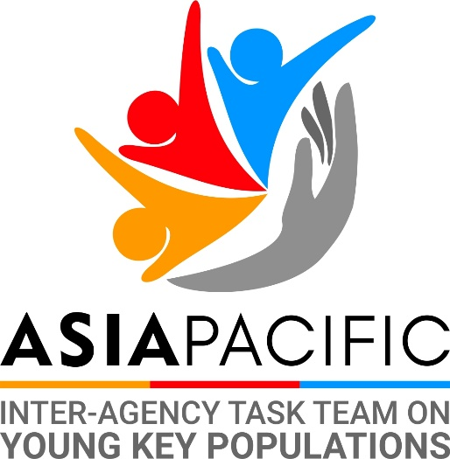
The logo design is an important tool when it comes to promoting and advocating for issues being brought by the Inter-Agency Task Team on Young Key Population. It must have a unique design that incorporates a design concept and colors elements in a special way that it conveys the joint work of the different agencies and organisations towards achieving the rights of Young Key Population. The logo should be able to make a lasting positive impression on the audience and encourage them to be supporters and eventually take part in ensuring that the rights, opportunities and services are ensured for all young people, especially young key population.
The logo designed was made by Sean Alfred, a United Nations Volunteer through the Online Volunteer programme.

Highlights in 2018

En Route to Adulthood Brainstorming Workshop
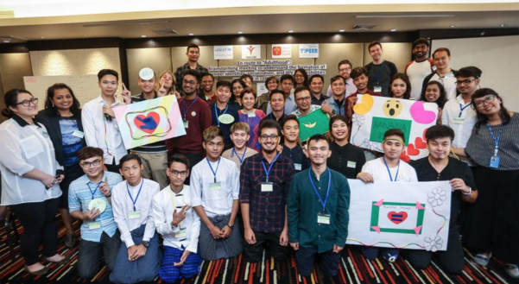
The En Route to Adulthood Brainstorming workshop explore the formation of gender identities, socialization and HIV vulnerabilities of adolescents was held in Bangkok from 26–27 March 2018. Hosted by the United Nations Children’s Fund’s East Asia and Pacific Regional Office (UNICEF EAPRO) and South Asia Regional Office (ROSA) in partnership with Youth Voices Count, Youth LEAD, Y-PEER, UNESCO Bangkok, UNFPA Asia Pacific Regional Office, UNAIDS Asia and the Pacific.
A total of 23 participants attended the workshop and included five adolescents and 18 representatives from young key populations – young men who have sex with men and transgender people – from Bangladesh, India, Indonesia, Myanmar, Nepal, Philippines, Thailand and Viet Nam. In order to narrow the scope of this consultation, the participants invited were all assigned male at birth. The age range of the participants was 17 – 27 years of age, with an average age of 20. Most participants were from 19 to 21 years of age. Other attendees included representatives from UNICEF New York, UNFPA, UNAIDS, UNESCO, Assumption University of Thailand and the Asia Pacific Coalition on Male Sexual Health (APCOM).
Follow up meetings and discussions happened after the brainstorming workshop together with members of the IATT. It is proposed that a formative assessment is conducted to further explore the four areas (education, parental/peer support, communications and mental health) in four or five countries in the region. The assessment will specifically focus on understanding the perspectives and experiences of adolescents and youth most vulnerable to HIV, including differences among sexually and gender diverse adolescents and youth, as well as commonalities and differences when it comes to the larger segment of adolescent girls and boys; and how certain sociocultural norms, expectations and socio-political frameworks further constrain healthy development for these adolescents and young people (MSM and transgender people) who are at a higher risk for HIV.
The assessment will investigate and consolidate the most critical issues and the relevant support needs for adolescents and youths at risk. Specified countries are Indonesia, Thailand, Philippines and Viet Nam.

TeenGen Leadership Programme
TeenGen Leadership Program was organized in Goa, India from 3rd to 7th May 2018 by Human Touch NGO with the support of UNAIDS India, YouthLEAD, and other partners.
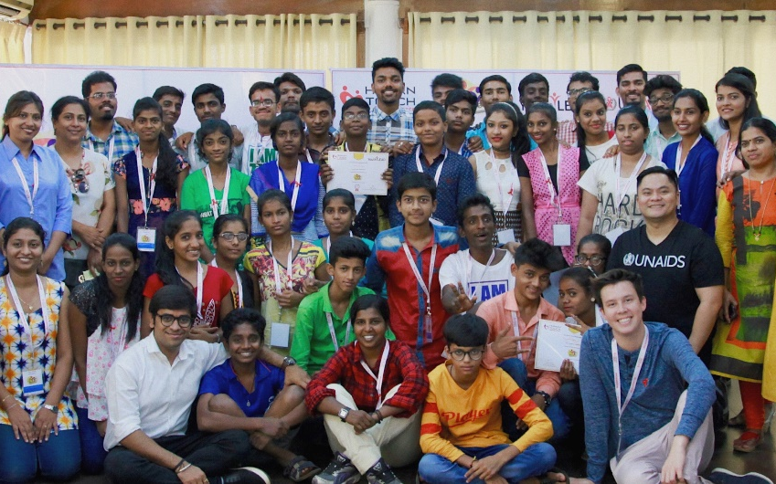
The participants identified different issues experience by adolescents living with HIV in India including difficulty in adhering to treatment, lack of proper nutrition, misinformation on HIV, and discrimination. “I am grateful to UNAIDS and Youth LEAD for making TeenGen a possibility here in India,” said Chinmay Modi, a young activist from the Network of People Living with HIV and a facilitator at the workshop. “This is the first time we have this kind of programme where adolescents lead, and they are able to discuss their issues with each other.
A clear outcome of TeenGen is a plan to build an informal network of young people living with HIV in India. This will also be supported by UNAIDS through #uproot, a global, youth-led political agenda based on the principles of equity, inclusion and solidarity, aimed at ending AIDS by 2030 and advancing sexual and reproductive health and rights, by tackling the barriers, bigotry and exclusion that jeopardize young people’s health.
More Details on https://bit.ly/2xDIWaK

Regional Training of Trainers on the Legal Advocacy Toolkit
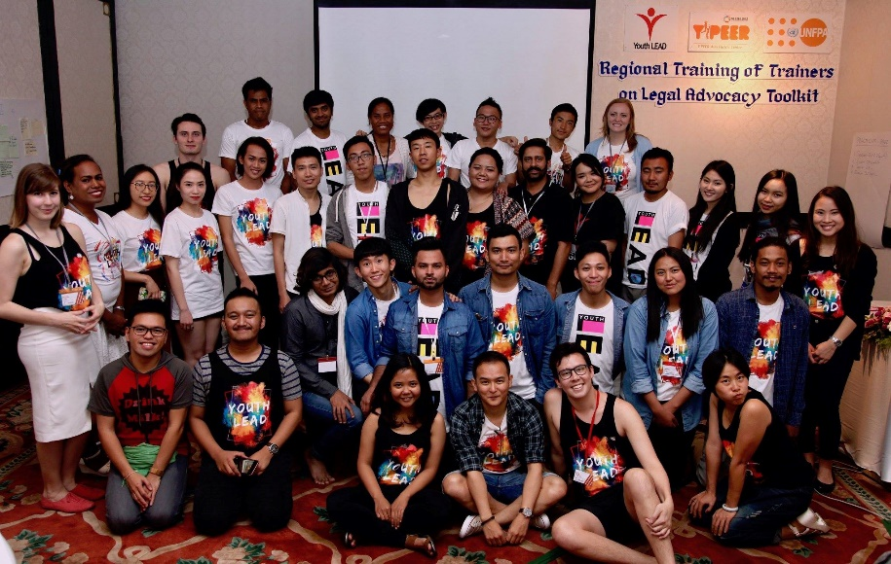
On May 27th-29th 2018, YouthLEAD in partnership with Y-PEER, UNFPA and IATT-YKP held a regional training of trainers on the Legal Advocacy Toolkit in Bangkok, Thailand. The training involved 25 participants, representing 16 countries from the Asia-Pacific Region.
The goal of this training was to inform participants of the impact of laws and policies, and how they can get involved to become more knowledgeable surrounding these technical topics. The training involved seminar-style lectures as well as interactive activities to get participants working with the material they were learning. On the last day of the training, a simulation UNESCAP meeting was held for participants to present their proposals on an aspect impacting the lives of Young Key Populations (YKP). We hope that through this training, the participants involved can disseminate this information to others in their network, and to ultimately have a positive impact for YKP.

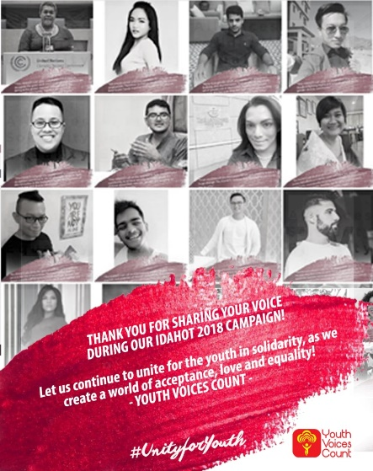
IDAHOT 2018
This year’s International Day against Homophoba, Biphobia and Transphobia (IDAHOT) has a global theme, “Alliances for Solidarity, inviting agencies, organizations, individuals and allies to take a collective stand to fight intolerable acts of discrimination, oppression, marginalization and exclusion of members of the lesbian, gay, bisexual, transgender, intersex and queer community. The world today is in the forefront of battling systematic injustices against the LGBTIQ community and this IDAHOT, it is more crucial, than ever, to join hands and collectively stand for equality and acceptance.
Campaigns and statements made by members of the IATT on YKP are as follows:
- #YouthVoicesCount #UnityForYouth Campaign with memes from young people and allies showing the “Alliance for Solidarity": https://bit.ly/2OQRYI6
- UNFPA Statement for International Day Against Homophobia, Biphobia and Transphobia 2018: https://bit.ly/2QXpNZg
- PRESS STATEMENT: UNAIDS calls for strengthened partnerships to leave no one behind: https://bit.ly/2rOrpZP

Regional Consultation on Implementation Toolkit for Young Key Population

Over the last four years, various global, regional and national partners including donors, UN agencies, technical partners and key population networks have collaborated to develop the key population implementation tools for sex workers (SWIT), men who have sex with men (MSMIT), people who inject drugs (IDUIT) and transgender people (TRANSIT).
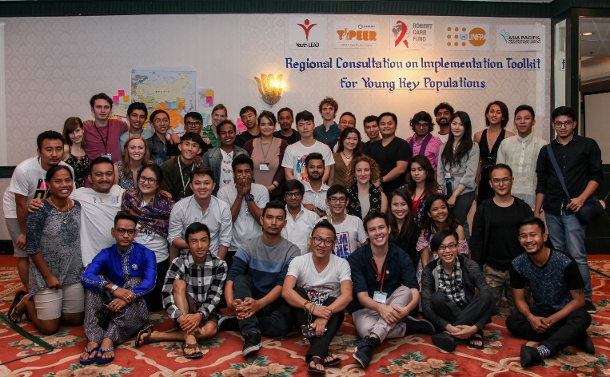
The tools have been referenced as the strategic and guiding document to develop national programs on HIV and key populations and importantly to develop Global Fund proposals relating to programming for key populations. UNFPA, UNODC, UNDP and other partners have continued to actively promote and support uptake of the tools at country and regional levels over the last year.
However, these implementation toolkits do not cater and incorporate the unique needs of youth cohorts within the key populations known as young key populations (YKP). YKP technical briefs are developed by WHO in collaboration various partners and youth-led organizations. The briefs are great advocacy documents and provide rationale to invest on the programming of YKP but they do not provide sufficient guide to develop interventions on YKP.
Similarly UNFPA and IPPF from EECA region has come up with A Practical Tool for HIV and Sexual and Reproductive Health Programmes with Young Key Populations in Eastern Europe and Central Asia, much similar to the implementation toolkit for YKP. The toolkit however is specific to EECA region. With this back-drop, with support from the UNFPA AP and the Global Fund CRG Special Initiative grant, Youth LEAD aims to develop the agenda for regional Implementation toolkit for YKP specific to Asia and the Pacific. The process aims to build the team of YKP champions and technical consultant to review the existing Implementation toolkit, technical briefs and EECA regional YKP toolkit and develop agenda for the YKP toolkit for Asia and the Pacific region.

22nd International AIDS Conference (AIDS 2018)
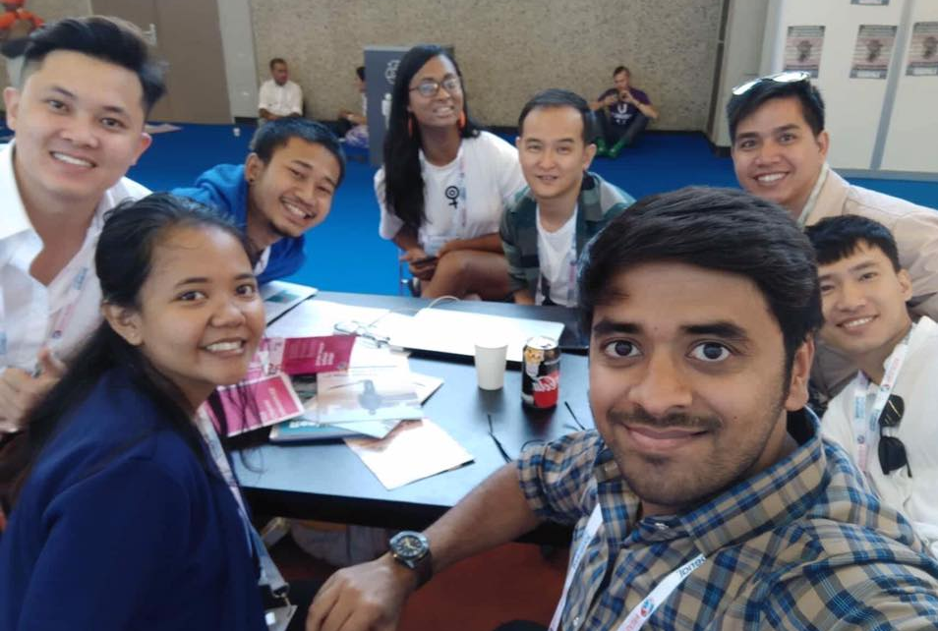
The International AIDS Conference is the largest conference on any global health issue in the world. First convened during the peak of the AIDS epidemic in 1985, it continues to provide a unique forum for the intersection of science, advocacy, and human rights. Each conference is an opportunity to strengthen policies and programmes that ensure an evidence-based response to the epidemic. The 22nd International AIDS Conference (AIDS 2018) was hosted in Amsterdam, Netherlands 23-27 July 2018.
The theme of AIDS 2018 is “Breaking Barriers, Building Bridges”, drawing attention to the need of rights-based approaches to more effectively reach key populations. AIDS 2018 aims to promote human rights based and evidence-informed HIV responses that are tailored to the needs of particularly vulnerable communities -- including people living with HIV, displaced populations, men who have sex with men, people in closed settings, people who use drugs, sex workers, transgender people, women and girls and young people--and collaborate in fighting the disease beyond country borders.
During the AIDS 2018, members of the IATT-YKP actively took part in the programme and discussion, especially in issues with youth and young key population.

International Youth Day 2018 Celebration

The 2018 International Youth Day theme is ‘Safe Spaces for Youth’, dedicated to ensuing the dignity and safety of youth. It’s widely acknowledged that youth need safe spaces where they can come together, engage in activities related to their diverse needs and interests, participate in decision–making processes and freely express themselves.
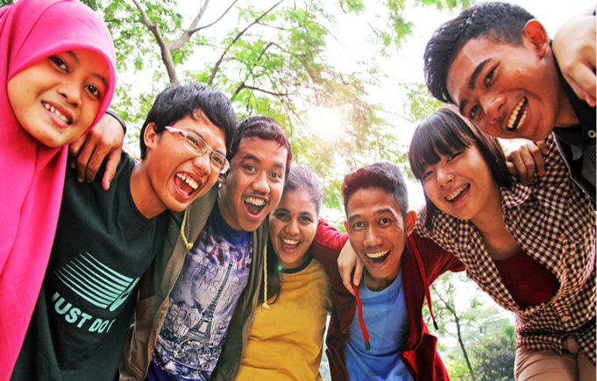
For this year’s International Youth Day, the Interagency Task Team on Young Key Population (IATT YKP) and Thematic Working Group on Youth Peace & Security (TWG YPS) would like to share inspiring stories from select young people across Asia-Pacific on their struggles and commitments on working in the fields of sexual and reproductive health and rights, young key populations, comprehensive sexuality education, humanitarian response, and youth, peace and security – all in connection with safe spaces.
Here are links to stories of safe spaces from inspiring young activists and leaders:
Justin Francis Bionat is the project officer of Youth Voices Count, a youth initiative founded in 2010 and led by young men who have sex with men (MSM) and transgender women. He is a young advocate of LGBTQ+ rights and sexual and reproductive health and rights, working at the local, national and regional levels.
Muhammad Sarim Imran from Pakistan has been working in the field of sexual and reproductive health and rights (SRHR) since 2013, starting as a volunteer with a local organization across a range of issues. Sarim was one of the first to raise his voice for the inclusion of sexual and gender minorities in SRHR projects in his region. Sarim is also an SRHR advocate for Rutgers Pakistan’s Youth National Advocacy Alliance.
We would also like to share a feature story: Youth voices count and safe spaces do too
A global coalition of more than 80 youth organizations working on HIV (the PACT), and Youth Voices Count (YVC) launched a poll to get a sense of what young people know about sexual reproductive health. More than half of the 270,000 young people aged 10-24 from 21 countries who responded to the U-Report poll (54% of boys and young men, and 58% of girls and young women) sought HIV and other services at a health centre or clinic in the previous three months. About 36% of young people aged 10-24 who did not seek services reported feeling uncomfortable visiting a health centre or clinic, and more than 28% of young people (both sexes) said they felt scared to seek services. Read more here.

Bangkok International Run 2018
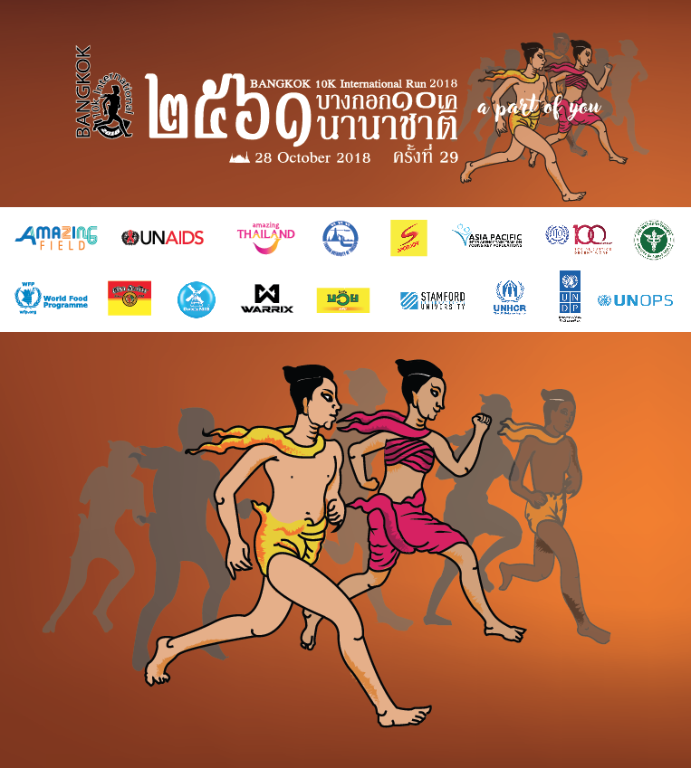
The Bangkok 10km International Run, takes place every year to promote the right to health and tackle HIV related stigma and discrimination in Asia and the Pacific. This year it 8,000 people joined the run which was held in 28 October around the area of the United Nations ESCAP.
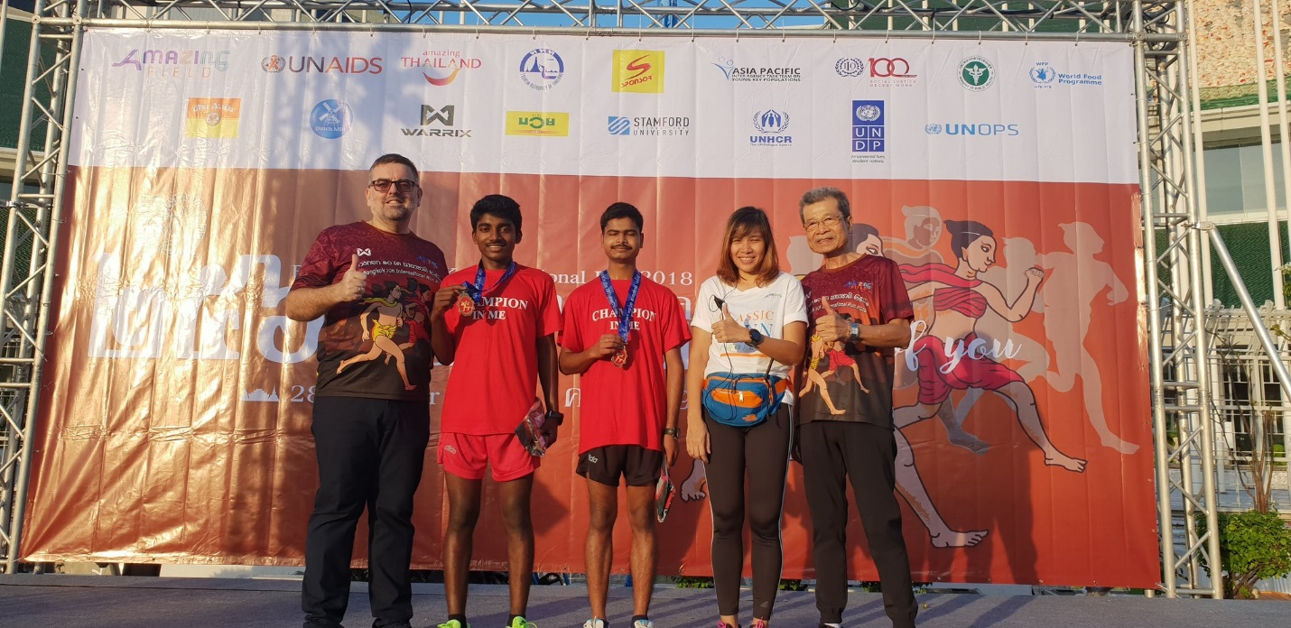
For this event, athletes Babu Seenappa and Manik Prabhu, two exceptional young marathoners born and living with HIV from India, participated representing the Bangalore Schools Sports Foundation: Champion in me. Both athletes continue to live with outstanding achievements & hard work in building a world free of stigma and discrimination. “We have not let HIV stand in our way of achieving our dreams. We are running not just for ourselves, but for all our friends and people who are living with HIV. With treatment, people living with HIV can live healthy and long lives and work productively. We are standing up for our rights to education, participation in sports, employment and quality healthcare”, says Babu and Manik.
The run is a partnership between the Joint United Nations Programme on HIV/AIDS (UNAIDS) and the event company Amazing Field, in collaboration with the Tourism Authority of Thailand, the Commercial Company of Siam and Redbull Beverage, and supported by the Ministry of Public Health of Thailand, the Asia Pacific Interagency Task Force on Young Key Populations, ILO, UNDP, UNHCR, UNOPS, WFP and Stamford University.
A portion of the proceeds will be donated to UNAIDS and parner-led initaitve to help reduce stigma towards people living with and affected by HIV.

World AIDS Day 2018
December 1 every year the world AIDS day is held in respect to the many victims of AIDS. It likewise centres on issues encompassing HIV and (AIDS) awareness. It originated at the 1988 World Summit of Ministers of Health on Programmes for AIDS Prevention. Since then, every year United Nations agencies, governments and civil society join together to campaign around specific themes related to AIDS. This year’s theme for World AIDS Day, which will be marking its 30th anniversary on 1 December, will be “Know your status”.

IATT YKP Work Plan

Outcome 1: Young people from key populations in the Asia-Pacific region are engaged and capacitated to contribute to national HIV responses to improve their health, well-being and to realise their sexual and reproductive health rights
Activity/Programme | Intended outcomes | Agencies | Notes
- Mentoring programmes  2.1 Ignite programme  2.2 New Gen mentoring programme | - New generation of YKP advocates capacitated and mentored in participating in the HIV response. | YVC, APCOM, UNAIDS, UNICEF  Youth LEAD | Ongoing  2nd round of small-scale projects to start in May. New training tool developed with MSMGF for next round. The project is resourced already, looking at partnerships with UN agencies at country-level.  2.2 Not started
- ICT (incl. Apps, e-health) in interventions | - Webinar on ICT platforms for young people in Asia-Pacific | UNFPA | Ongoing  Country-specific sessions showcasing ICT interventions
3. Teengen training roll out | - New generation of AKP advocates capacitated with leadership skills | Youth LEAD, UNAIDS, UNICEF | Roll outs planned in India, China, Vietnam and Thailand
4. HIV & SRHR Centers mapping Website  4.1 Innovative SRHR programs for YKP | - Facilitate to access the Services related to SRHR and HIV  - Innovative interventions to meet SRHR needs of YKP | Y-PEER  Y-PEER, Youth LEAD | Ongoing : Nepal, Bhutan, Mongolia*  Vietnam/Mongolia/Nepal/Bhutan
5. Small grants for YKP and youth-led organisations in AP | - Networks/organisations of YKP and young people strengthened for stronger advocacy | Youth LEAD/YPEER | 17 organisations in AP region
6. E-Course on SRHR | - Joint online E-Course for Young Key Population | YouthLEAD Y-PEER. UNFPA | TBD
Outcome 2: Strategic information are generated, synthesized and used to support regional level advocacy targeting governments and civil society to promote scale up of comprehensive evidence-informed interventions for YKP
Activity/Programme | Intended outcomes | Agencies | Notes
- Young people and HIV in Asia-Pacific data 2018 | - Data and information on the HIV epidemic among young people in Asia-Pacific, based on the GAM, collated and synthesized and utilized for advocacy purposes. | UNAIDS  IATT on YKP | On track
- Strengthening strategic information on adolescents from key populations and YKPs. | - SI on adolescents and YKPs are developed and strengthened and utilized for evidence for focused intervention and investments. | UNICEF  UNAIDS, YouthLEAD | Ongoing  Check with UNICEF  Analysis of the primary data on AKP in Nepal (Youth LEAD)
4. Regional consultations to the issues of SRHR in new strategic plan of Youth LEAD | - SRHR issues integrated in the Youth LEAD new strategic plan. | YouthLEAD, UNFPA | On track
5. Regional consultations to develop the HIV and SRHR programming toolkit for YKP-  Online survey to collect the inputs of YKP and stakeholders on the toolkit | - Identify the areas of adaptation of the Eastern Europe toolkit to the context of Asia and the Pacific | YouthLEAD, UNFPA | On track
Outcome 3: Scale-up evidence-informed, national programmes for YKPs through advocacy interventions with government, policy-makers and other stakeholders
Activity/Programme | Intended outcomes | Agencies | Notes
- Adolescent-friendly services  1.1 Jumping hurdles tool on youth-friendly health services.  Innovative YKP friendly services | - Service providers are equipped to better respond to the needs of young key populations.  - Tailored YKP friendly services designed and implemented | YVC  Youth LEAD | - Ongoing  1.1 YVC is selected as a grantee on the UNESCO (HQ) supported CSE Project.  Vietnam (Lighthouse)
- Health services mapping and case management of AKPs in X countries |  | UNICEF /Youth LEAD | Ask UNICEF  Youth LEAD: Report being finalised.
- Regional Guide for Global Fund implementers on young key population inclusive HIV programme | - CCMs, regional and country-level Global Fund Grantees engage YKPs and YKP-led network in development, planning and implementation of GF grants. | Youth LEAD  UNICEF, UNAIDS | On track  Regional guide already finalized. Youth LEAD creating consortia with Y-Plus and Youth Rise to apply for GF grant to cover evidence, dialogue, country processes and YKP-led watchdog mechanism. TA for 2 years.
- Engagement with ASEAN particularly Health Cluster 2 | - ASEAN Workplan on AIDS implemented with key engagement from the IATT members | UNAIDS, Youth LEAD, YVC, UNICEF, UNFPA | On track
- Develop CSE mapping and conduct workshop | - Conduct an in-depth mapping of select digital sexuality education initiatives and stakeholders in the Asia-Pacific region. The mapping exercise should include engagement with the creators/developers of these initiatives as well as gather user insight (where possible) on design, operational modalities and content. | UNESCO, UNFPA | On going  UNESCO will check status of CSE review in China, Thailand and India.  UNESCO interested in the promotion of CSE.  UNESCO HQ developing communications on CSE
6. Out of school CSE guideline development |  | Youth LEAD
Outcome 4: Increased advocacy for an enabling and coherent environment for YKP
Activity/Programme | Intended outcomes | Agencies | Notes
- Legal advocacy toolkit | - Generate and develop pool of champions on legal advocacy at the regional level  - Youth networks are capacitated to engage in national legal and policy advocacy.  - Awareness raised among governments on legal and policy barriers to services for young people including YKPs. | Youth LEAD,UNFPA  UNAIDS, UNDP, UNICEF | On track
Activity | Intended outcomes | Agencies | Notes
Bimonthly meetings of the Task Team  -Meetings convened bimonthly  -Agenda circulated in advance, with inputs from members  -Meeting minutes and action points circulated | -Increased opportunities for information sharing, learning and partnerships  -Monitoring of the workplan and actions undertaken | UNFPA, YPEER  All members
Engagement and inputs into other relevant mechanisms  -IATT inputs feed into other global-level mechanisms (i.e. IATT on Young People, IATT on key populations, and other global-level initiatives)  -IATT inputs feed into other regional-level mechanisms (i.e. IATT on Women. Girls, Gender Equality and HIV) and promote coordination | -Improved awareness of data, programme experience and programming on YKP in Asia-Pacific  -Improved coordination across Task Teams, reduced overlap and duplication of efforts | All members
Communication on the work of the Task Team  -Communications on Task Team activities available on the Internet (website, YouTube)  -Production of annual report. | -Greater awareness of the work of the IATT and use of IATT materials and programme experience | UNFPA, YPEER  All members

