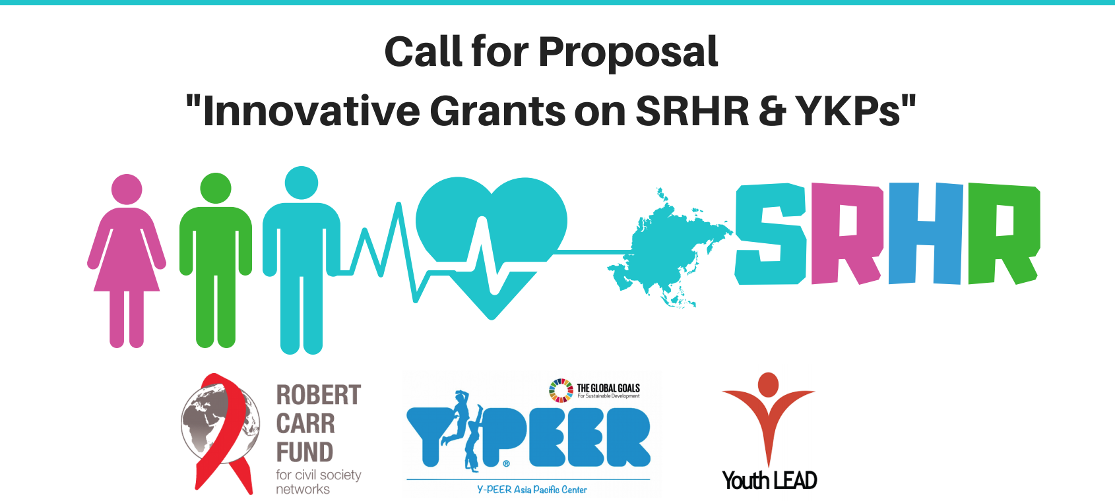

Background:
Youth LEAD and Y-PEER (Asia Pacific Center) have collaborated together to address SRHR needs of YKP at the regional and country level, pertaining to capacity development, policy influence, service delivery, community mobilization and evidence generation. One of the highlights of this collaboration has been to promote innovative ideas and initiatives from various youth and YKP-led organizations. This call for application is part of the continuation to identify new innovations and to turn them into successful practices within the region. The call is targeted to Sexual Reproductive Health and Rights (SRHR) and Young Key Populations (YKPs) led youth organizations working within the Asia Pacific Region.

Objectives:
The call for proposal is to bring out innovations on SRHR initiatives targeted towards YKPs.

What do we support?
The best innovative ideas that directly reflect the linkages between SRHR and YKPs including, but not limited to:
- Capacity development but not confined to mere trainings
- Policy advocacy
- Evidence generation
- Online/digital campaigns
- Solutions to effective service delivery
- YKP friendly SRHR services and information
- CSE for YKP

What we don’t support:
- Core cost e.g. rent and salary etc.
- One time events e.g. celebrating International Days or training
- Printing of IEC Materials without any purpose and follow up
- Purchasing of infrastructures
- Organizational development

Timeline

Proposal Submission:

Jun 20 2018- July 30 2018

Proposal Results:

August 10 2018 – August 20 2018

Activity Timeline:

September 01 2018- December 10 2018

Reporting Deadline:
December 20 2018

Who can submit the proposal?
- YKP-led national networks and groups
- Youth SRHR organizations and groups
- Students and individuals passionate on SRHR issues

Note: The groups here refer to the functional groups of YKP or young people but are not legally registered.

Within the countries mentioned below:
Afghanistan, Bangladesh, Bhutan, Burma, Cambodia, China, Cook Islands, India, Indonesia, Kiribati , Laos, Malaysia, Maldives, Marshall Islands, Micronesia, Mongolia, Nauru, Nepal, Niue, Pakistan , Palau, Papua New Guinea, Philippines, Samoa, Singapore, Solomon Islands, Sri Lanka, Thailand, Timor-Leste, Tonga, Tuvalu, Vanuatu, Vietnam

Amount:
The minimum amount of request is 2500 USD while the maximum is 5000 USD. The final amount will be decided by Youth LEAD Secretariat based on the quality and need of the application.

Number of rewards:

Maximum of 5 Applications will be selected for the grant.

Application Process:
Send your proposal along with the budget in the format provided in an annex 1 to the email address info@youth-lead.org before 12 am July 30, 2018.
The subject of the email should be Country Name_ INNOVATIVE GRANT 2018.

Application Evaluation:
Youth LEAD and Y-PEER Secretariat will evaluate the application and, if required, external stakeholders will be invited. The innovations within the key areas, population, methodology and outcome will be one of the key areas during evaluation of the application.

Reference Document:
http://youth-lead.org/wp-content/uploads/2015/06/Final-SRHR-report.pdf
*YKP: Young Key population which includes young people who use drugs, young people who sell sex, young gay men who have sex with other men, transgender populations, migrant workers and people living with HIV.
* SRHR: Sexual Reproductive Health and Rights

Annex 1: The application form

Name of organization/Individual/Group:

Country and address:

Website (if applicable):

Key contact person for TA application and contact email:

Key contact person telephone:

Organization summary
Is your organization YKP-led? YES or NO
Is your organization a legally registered nongovernmental organization?
YES or NO.

If YES, please provide the year of registration and relevant documents:

If NO, You can still apply for funding, but you must have a fiscal sponsor.

If you have a fiscal sponsor, please answer the following:

Name of the organization:
Year of registration:
Address:
Website:
When and why was your initiative founded? (Minimum 200 words)

Application request

What do you want to achieve and why? (Minimum 200 words)

How do you want to achieve? Explain the activities. (Minimum 300 words)

What are the immediate results (output)? (Minimum 200 words)

How do you sustain your achievement? (Minimum 200 words)

Budget details
Activities | Input description | Total amount

